**PROBLEM – 1**  List the city, state, and zip codes in the customer table. Your result should not have duplicates. (Hint: The DISTINCT keyword eliminates duplicates.)

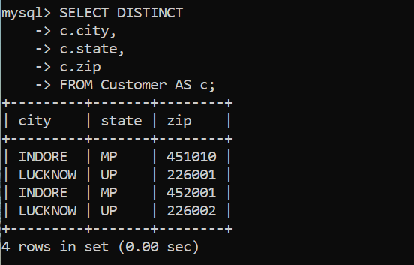

**SELECT DISTINCT**

**-> c.city,**

**-> c.state,**

**-> c.zip**

**-> FROM Customer AS c;**